**PROJECT DEPLOYMENT IN ASW CLOUD USING EC2 INSTANCE**

**Search for aws Academy Login.**

**Click on Student Login.**

**Enter your details and login.**

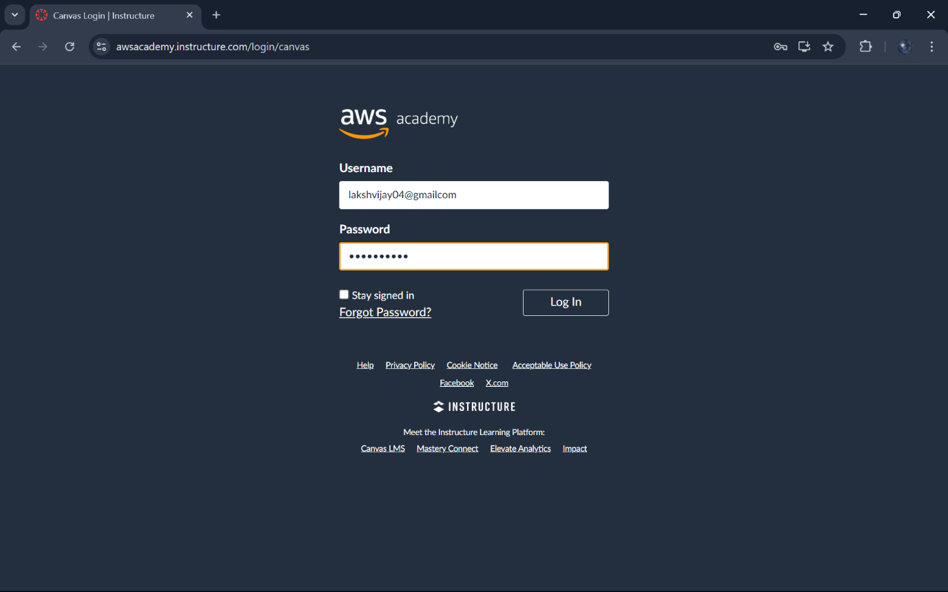

**Click on AWS academy learner lab.** 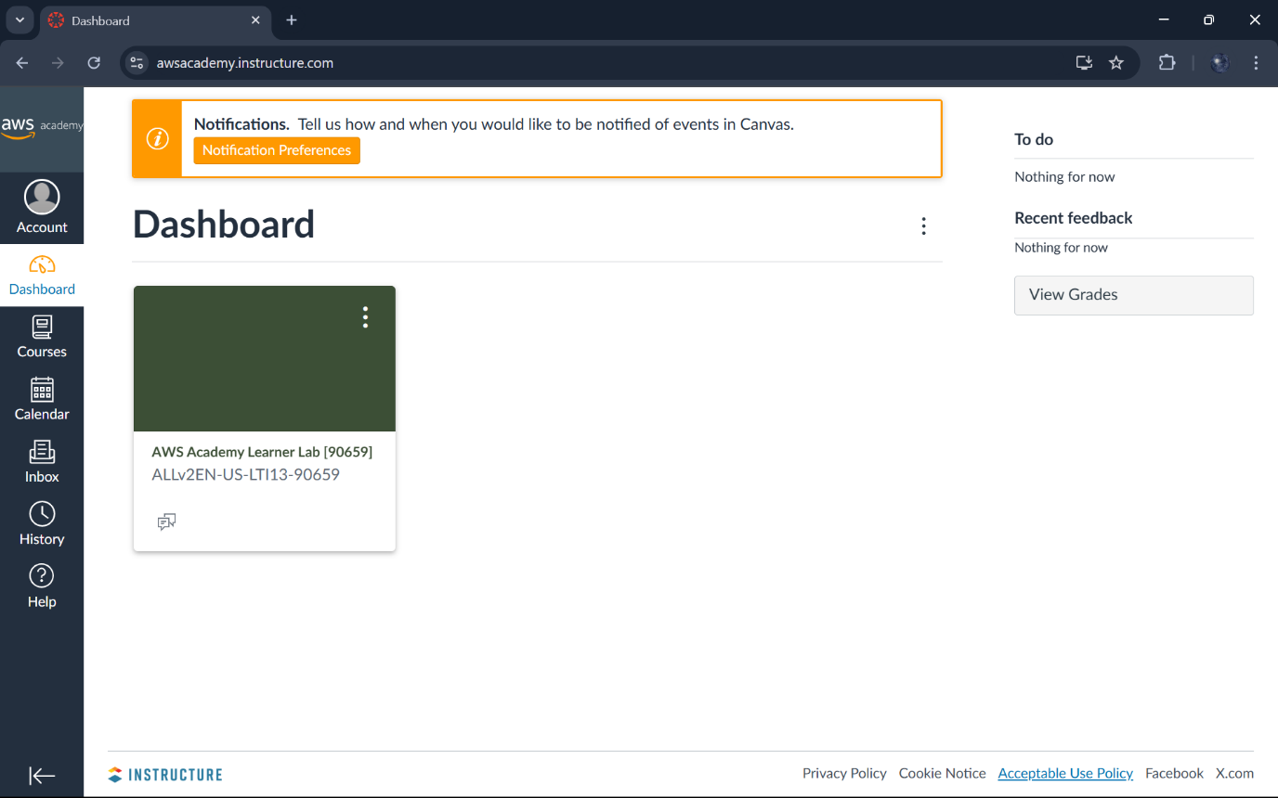

**Click on Start lab.**

**After the dots turned green click on it.** 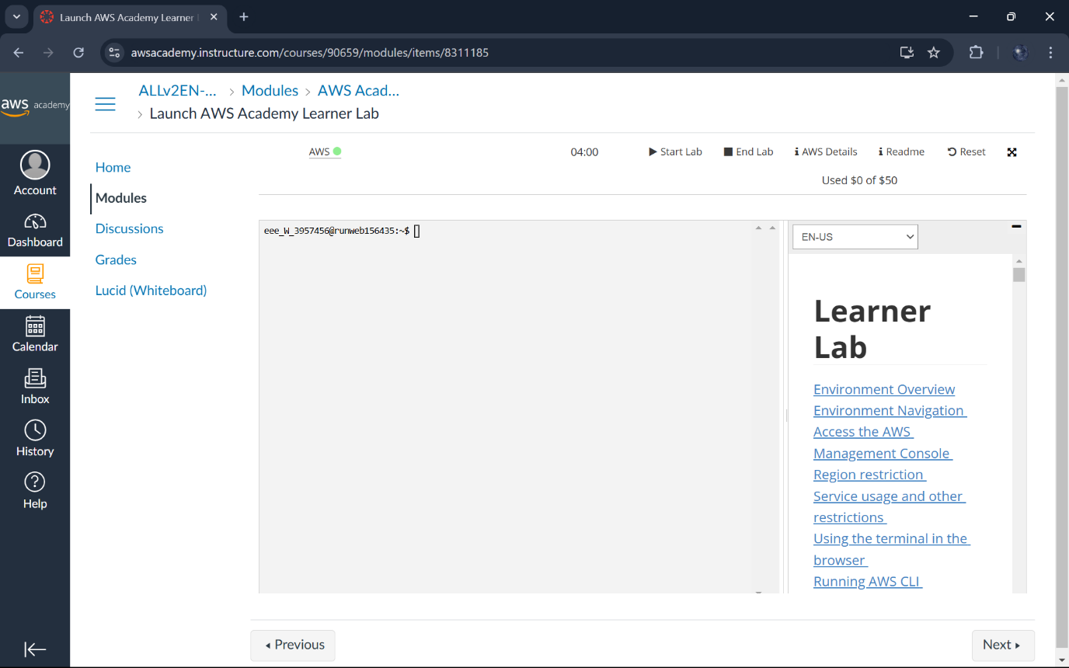

**Click on EC2 and click on Launch Instance.**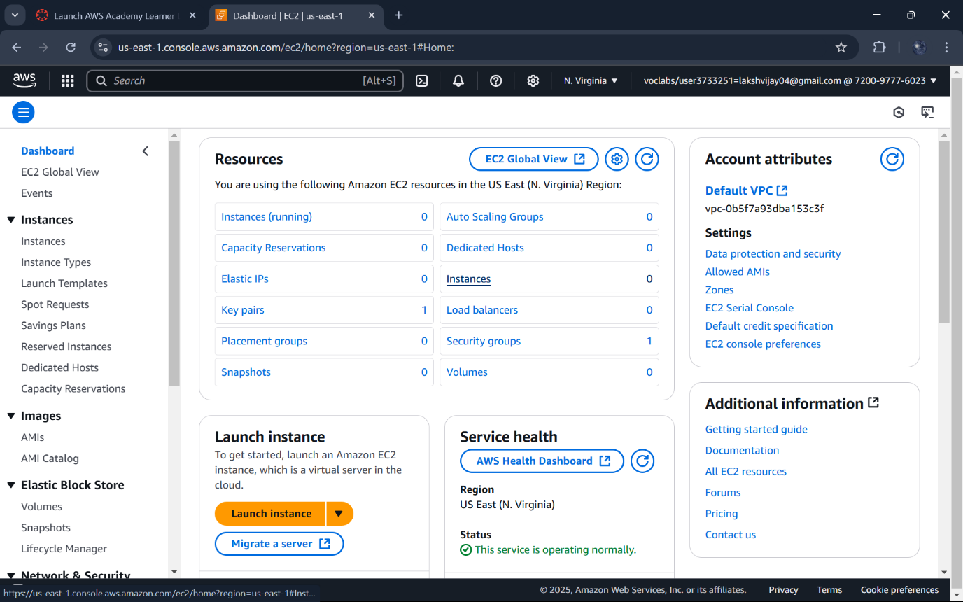

**Enter a name like “MyWebAWS” to identify your server.**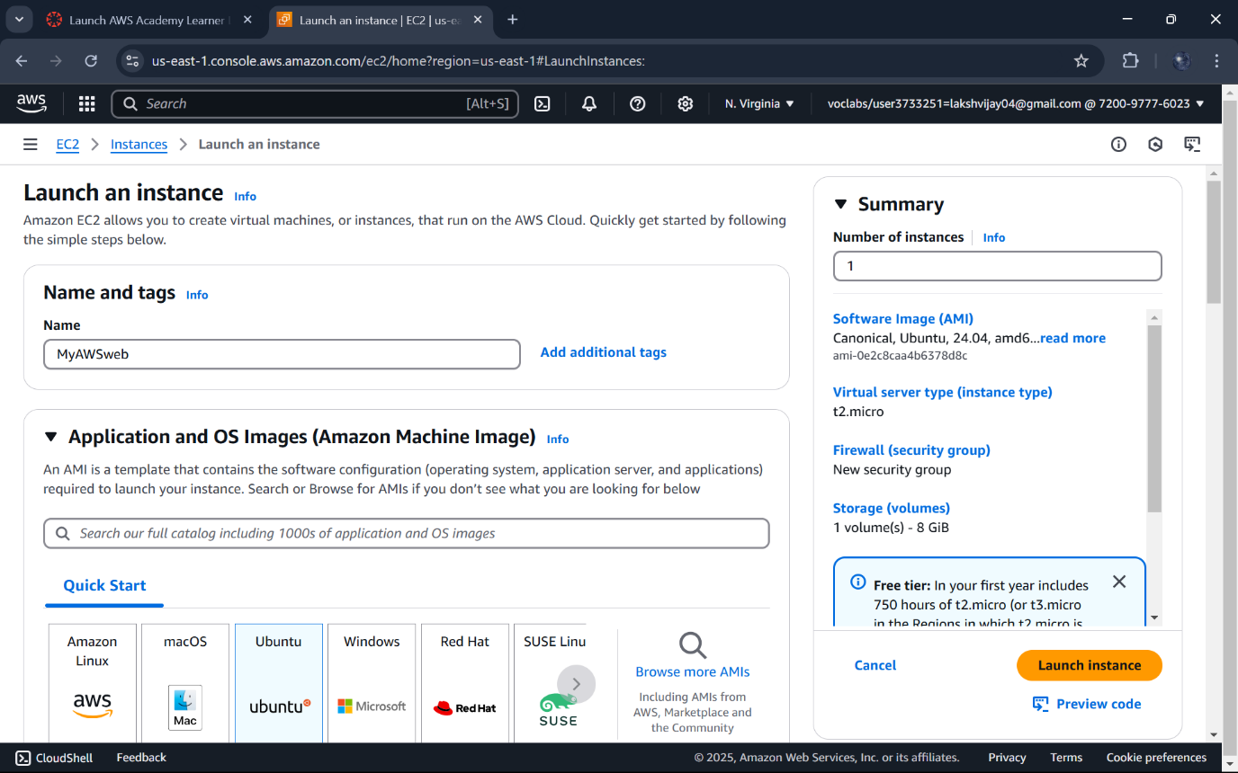

**Choose Ubuntu(free tire eligible)**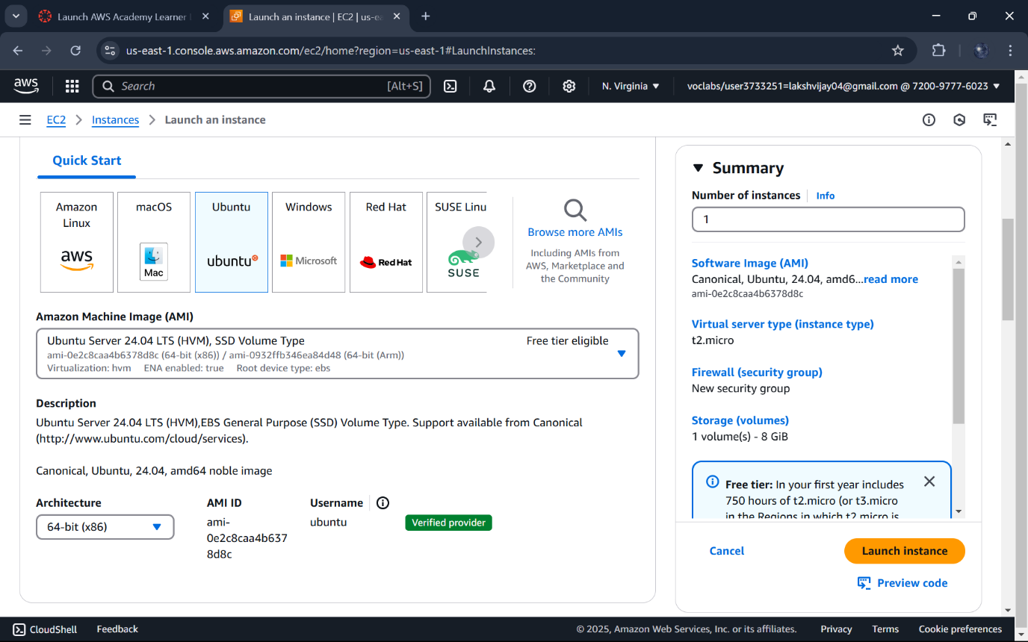

**Instance type:Select t2.micro(1 CPU,1 GB RAM)**

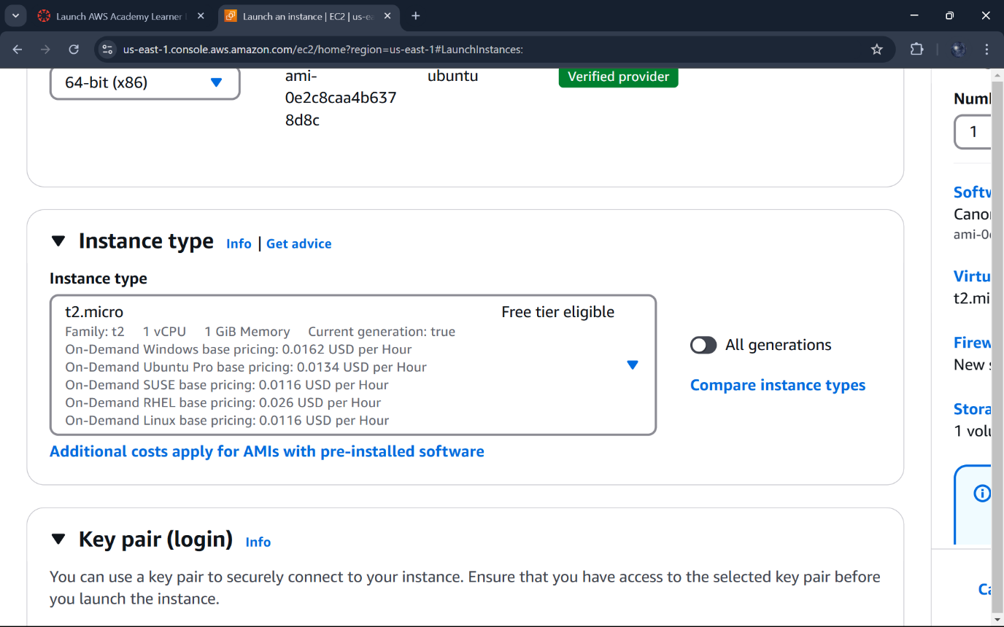

**Create a new key pair.**

**Give a name to your keypair and download the .pem file,and save it securely.** 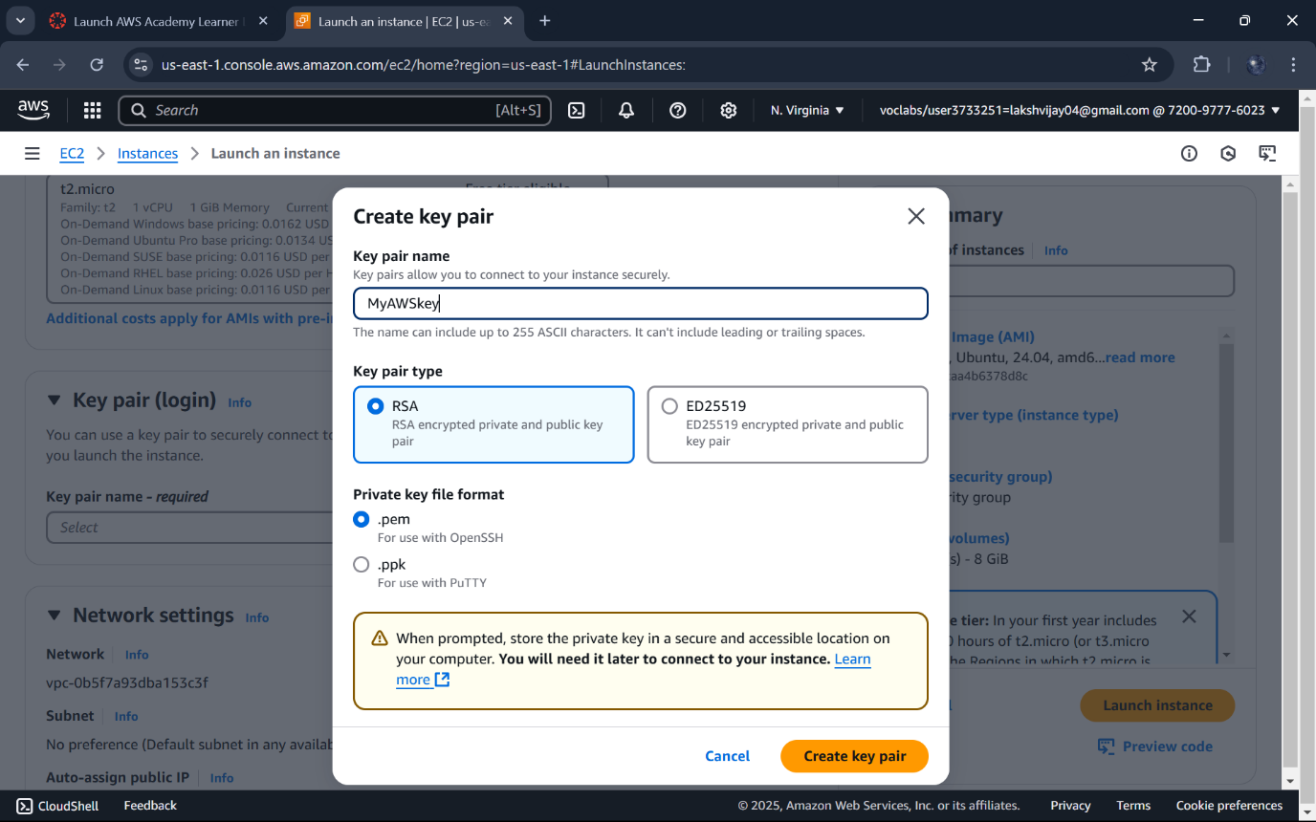

**Network:Enable Allow HTTP/HTTPS traffic to make your website accessible.**

**Use the default 8 gb.**

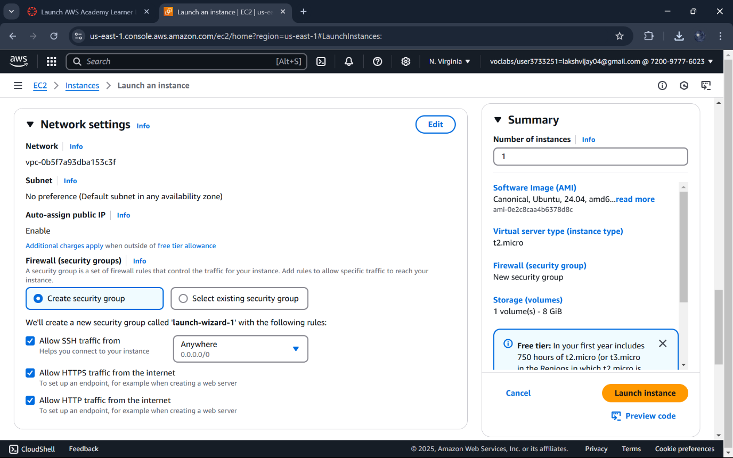

**The instance is initiated successfully.** 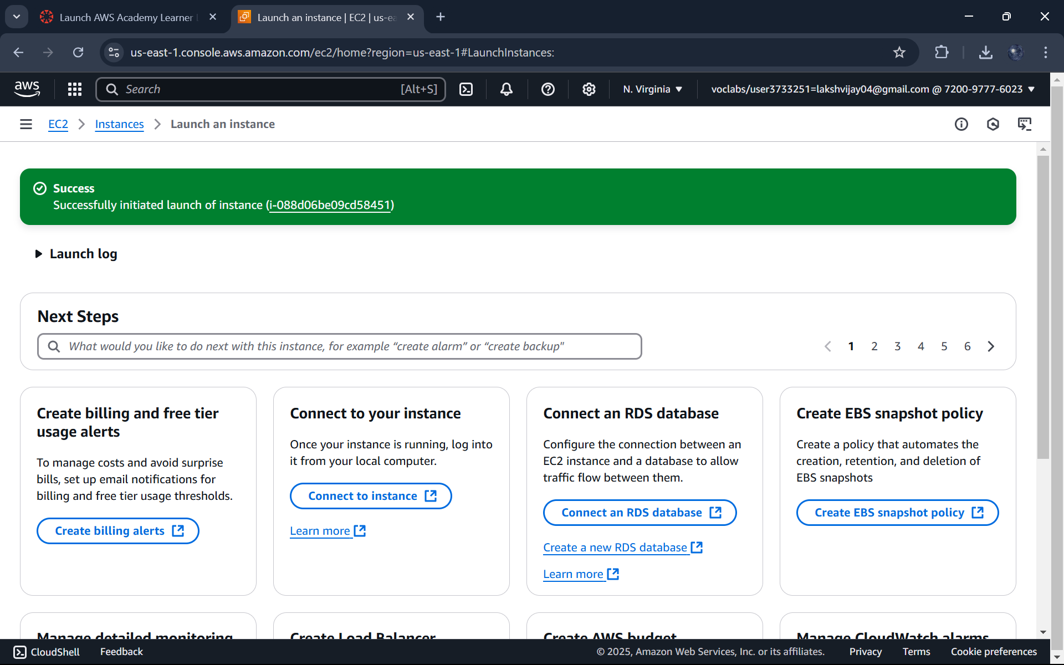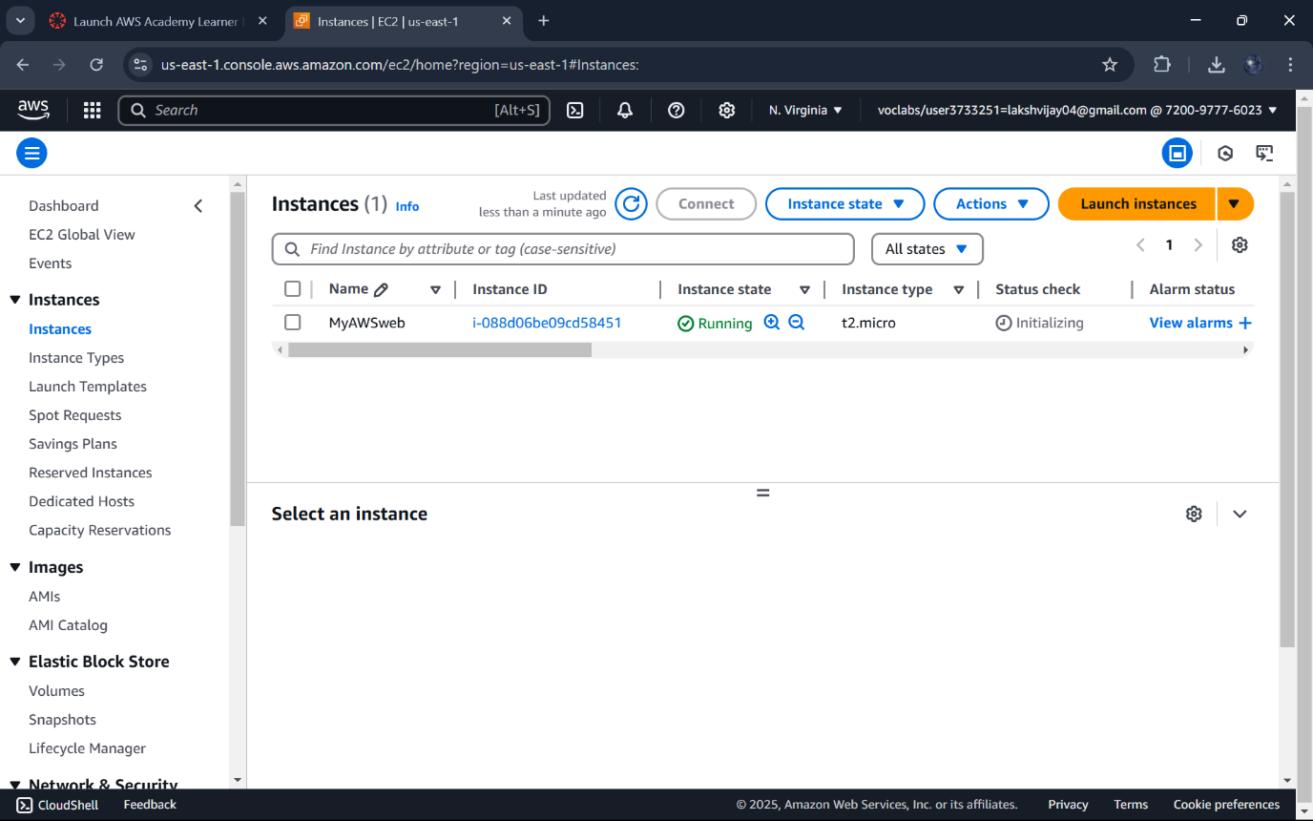

**Select your instance,click Connect,and copy the SSH command under Example Heading.**

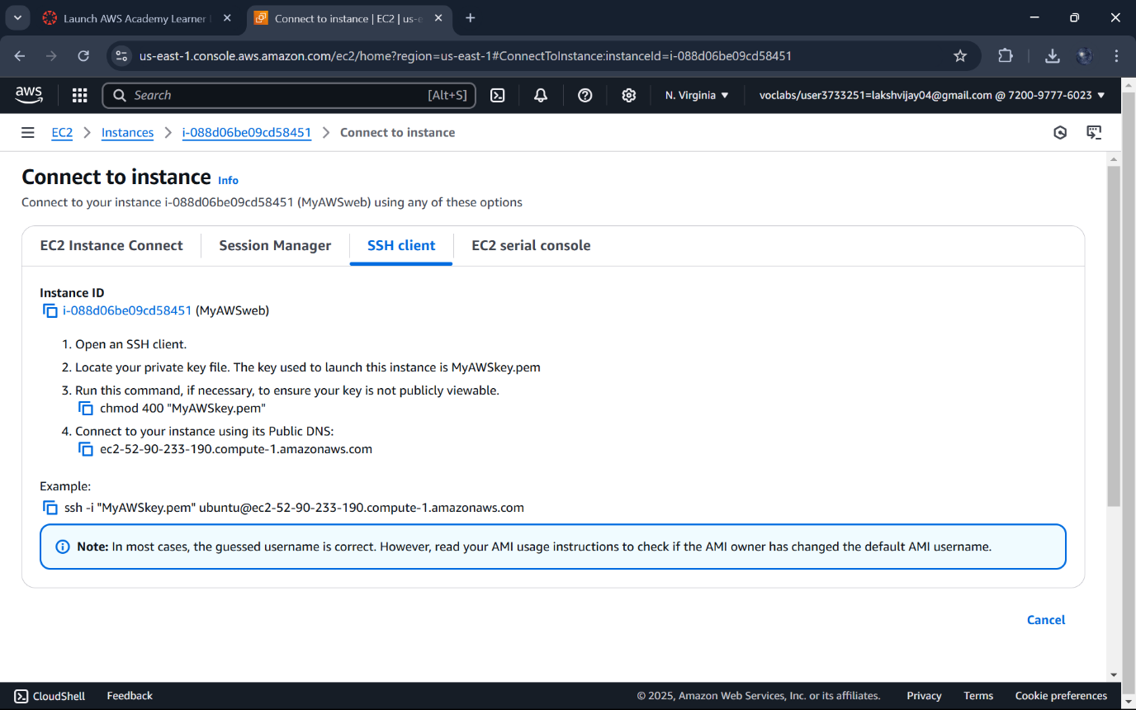

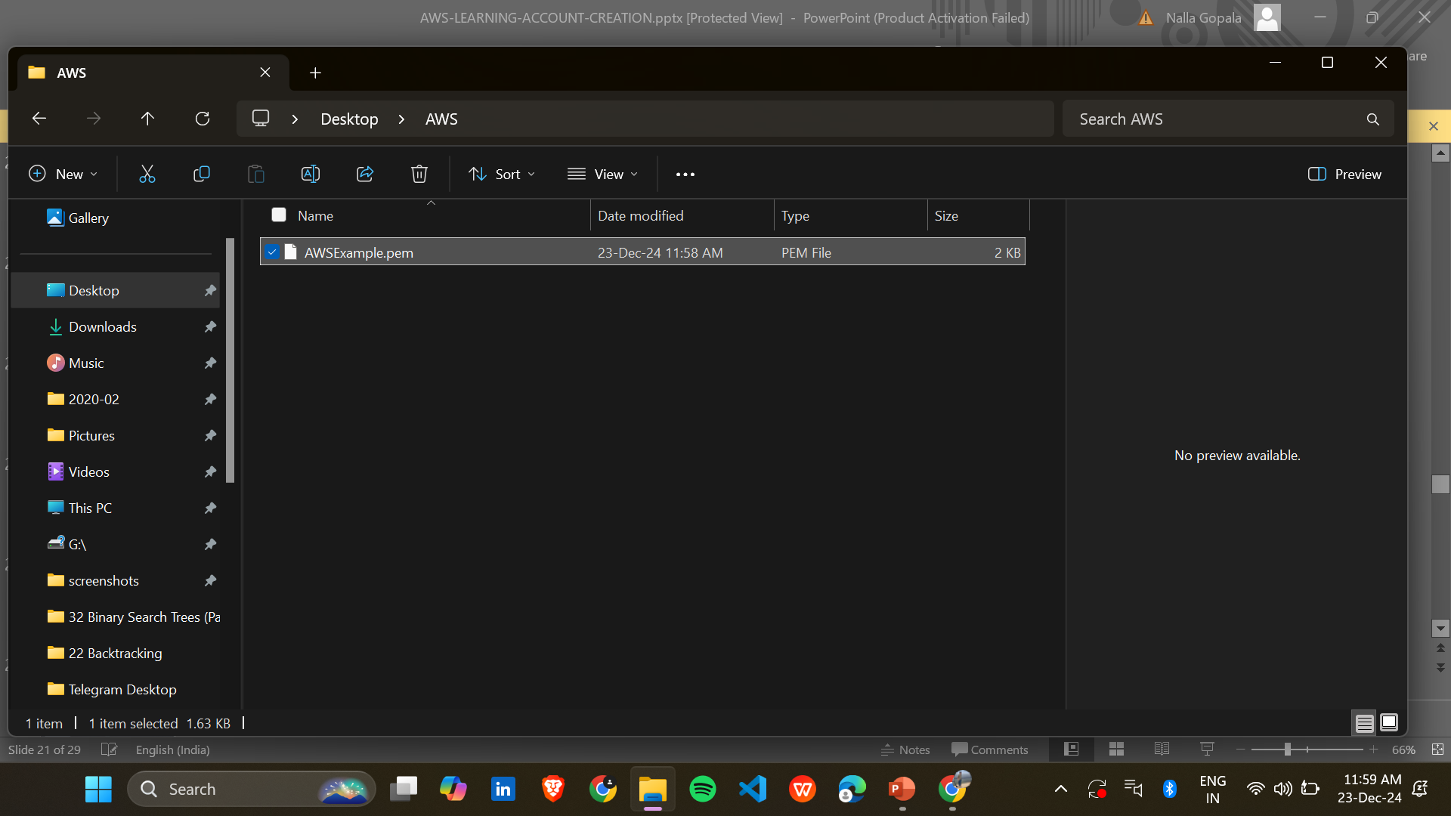

**Create a folder and copy the downloaded.pem file in it.**

**Copy the path of the folder.**

**Open powerShell on your computer and click on Run as Administartor.**

**Navigate to the folder where your .pem file is saved**

**Paste the ssh command and press enter**

**Type “yes” if prompted.** 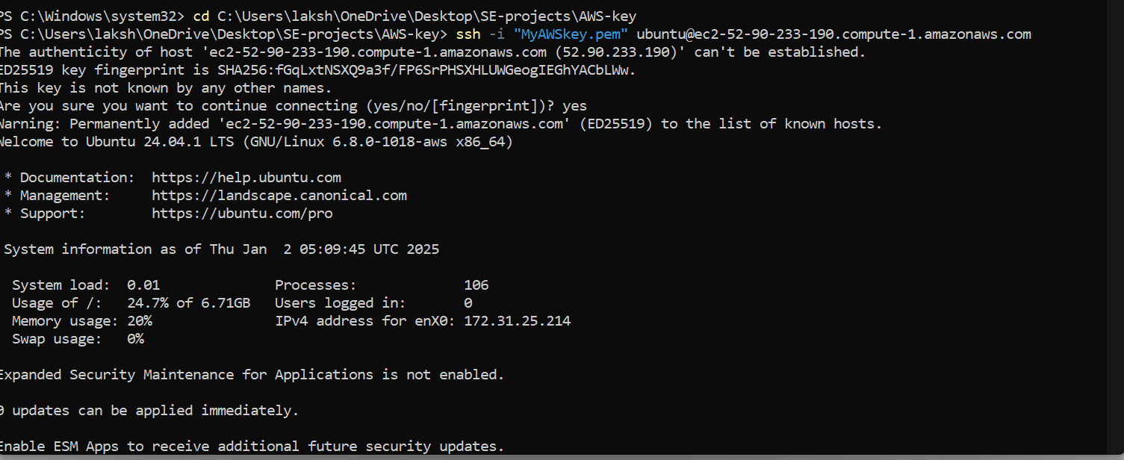

**Update the system to ensure using sudo apt update**

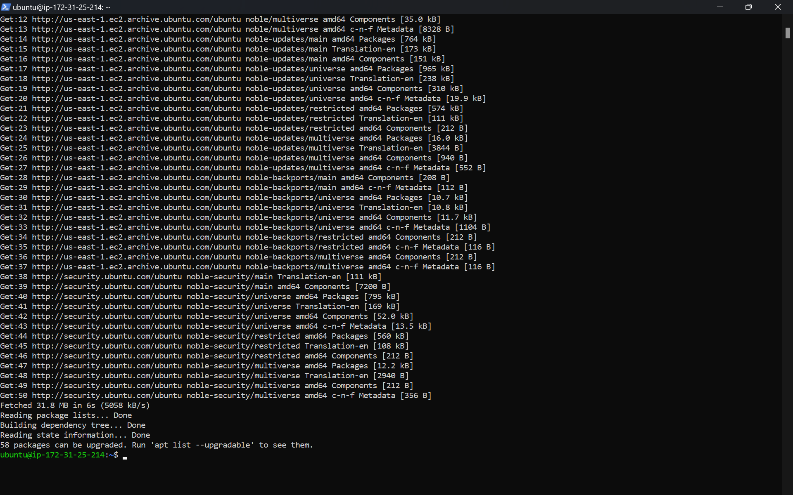

**Install Docker to package and run on web application.**

**Sudo apt-get install docker.io**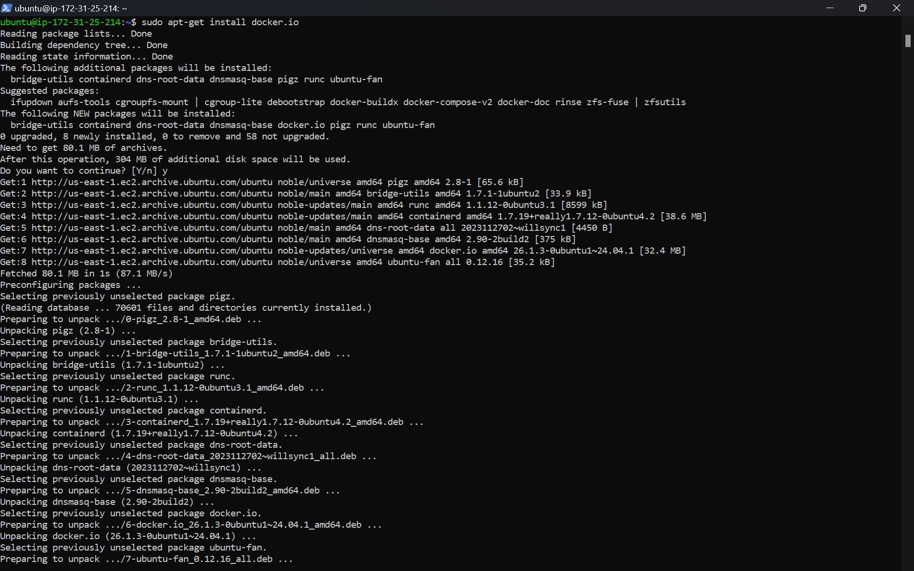

**Install git to manage and download code.**

**Sudo apt install git**

**Install nano for editing files directly on the server.**

**Sudo apt install nano**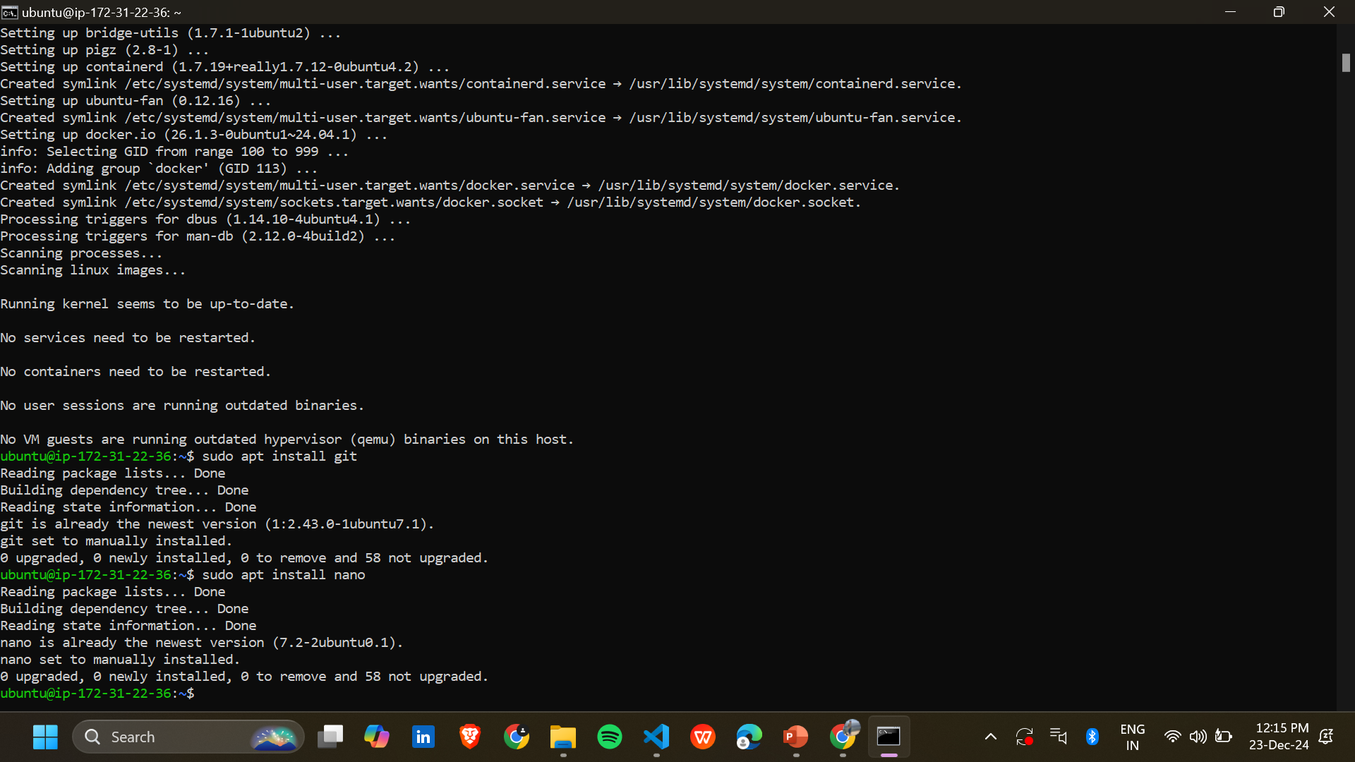

**Create your Web application**

**In this step ,we will build a simple page upload it to Github.**

**Create a folder in your Desktop.**

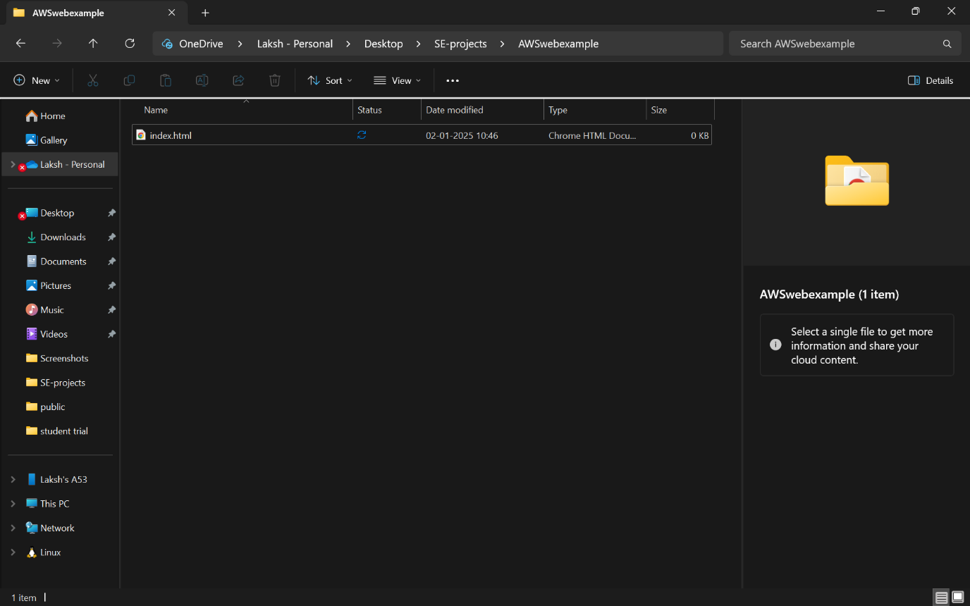

**On your computer,create a file named index.html and add the following content:**

**Hello from AWS**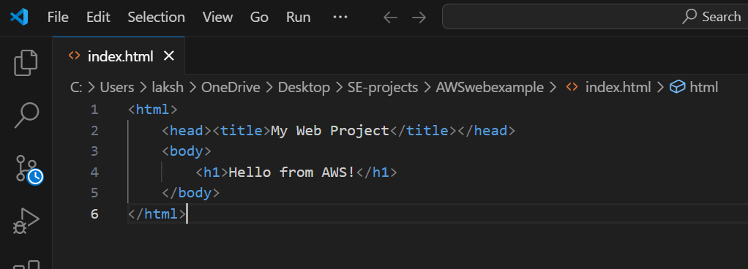

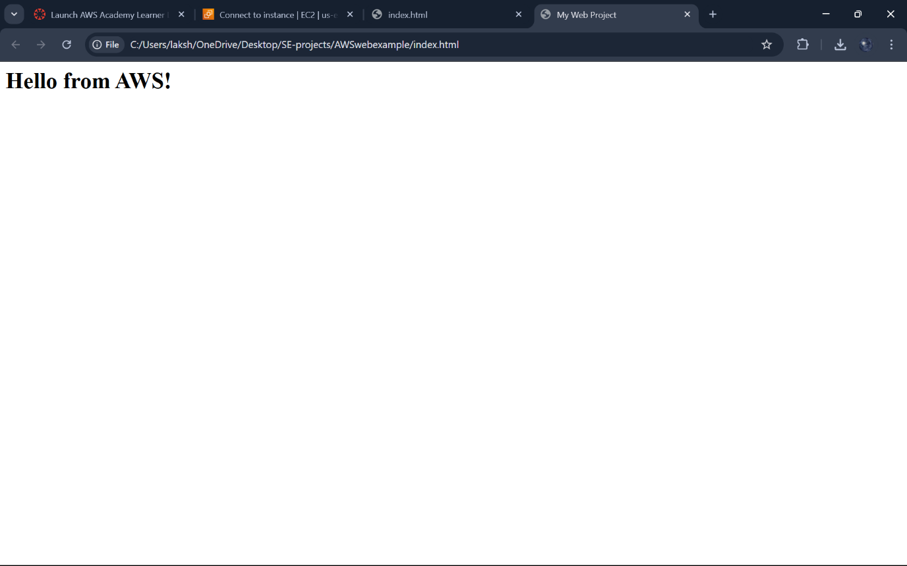

**Open your github account->Create new repository.** 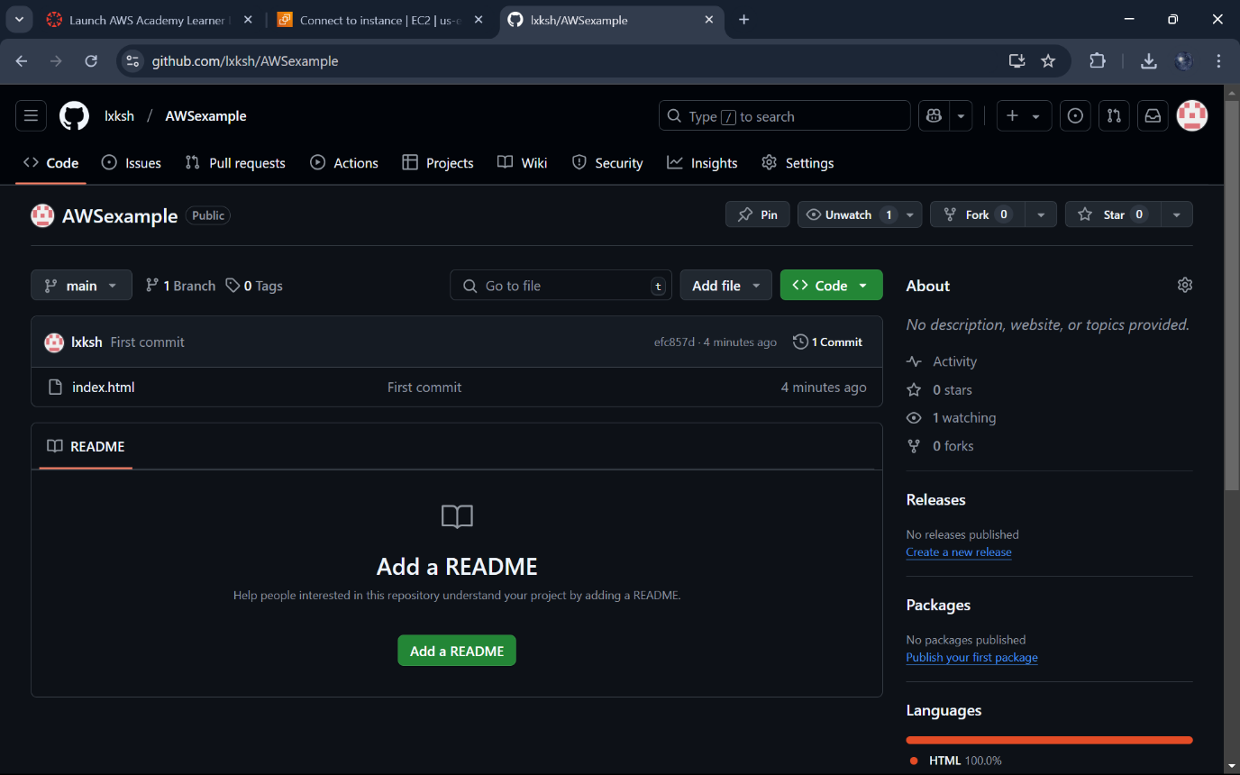

**Initialize git folder in it.**

**git add . to stage all changes**

**Git commit -m”First Commit” to commit the changes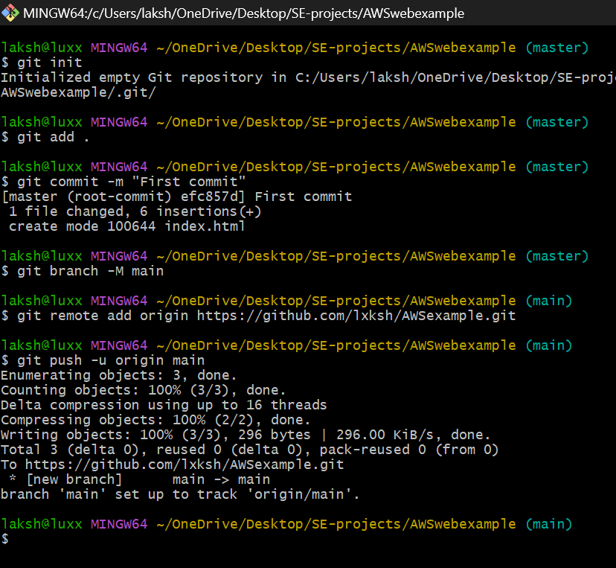.**

**On the EC2 instance,clone your GitHub repository:**

**git clone “your repo URL”**

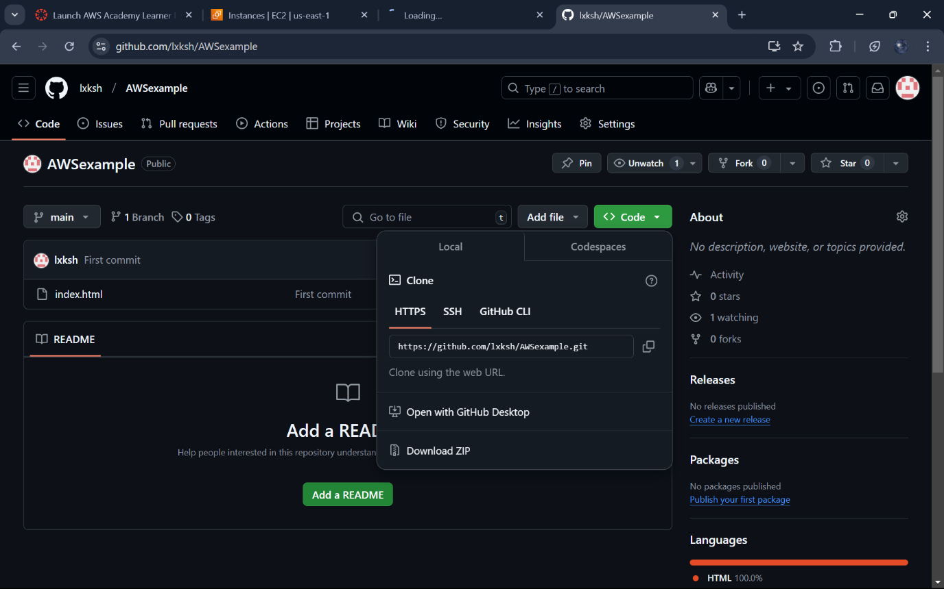

**Check if repo is cloned or not by typing ls.**

**Change your directory to the repo.**

**Build Docker container**

**Sudo docker build -t mywebexample**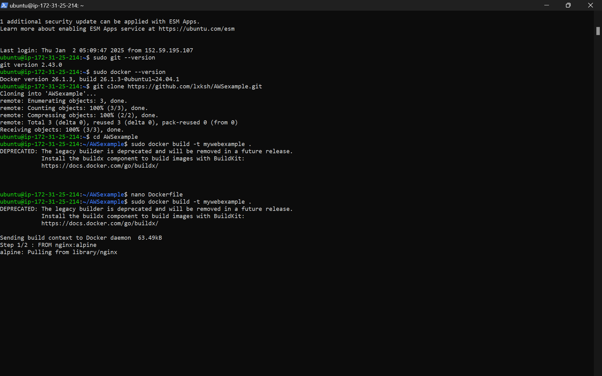

**Add the above content to the file**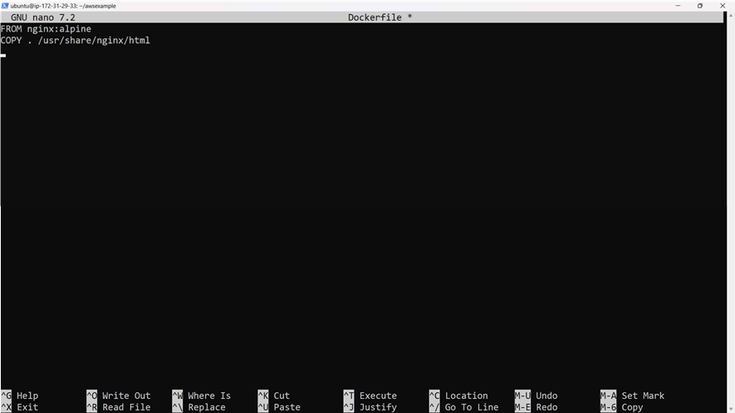

**Run the docker container to serve the web application:**

**Sudo docker run -d -p 80:80 mywebexample**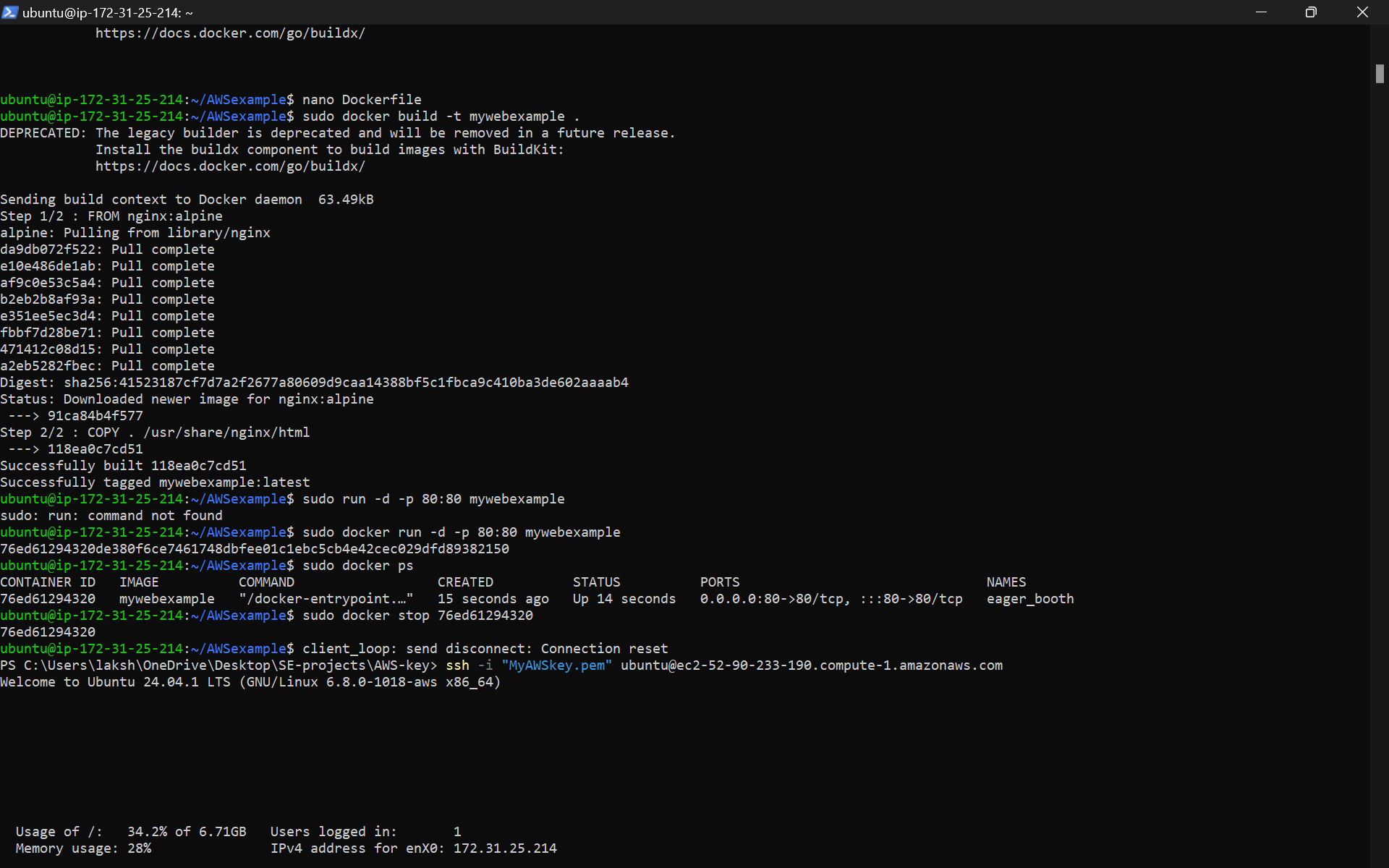

**You will get output like this.**

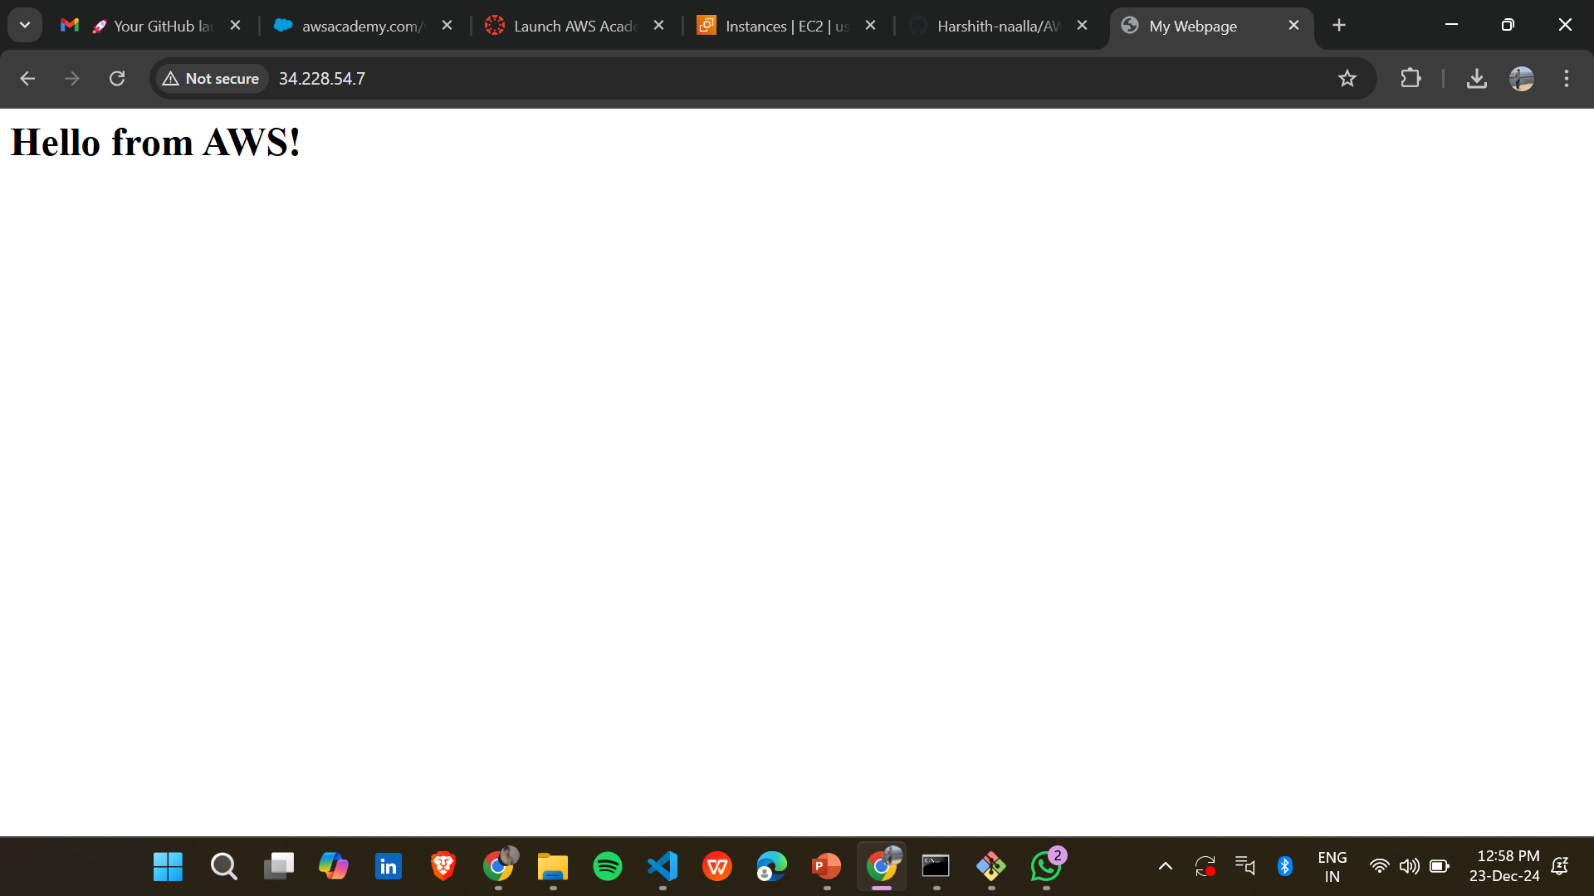

**After running docker file stop it by using it’s container ID**

**Terminate the EC2 instance in the AWS console by selecting it.**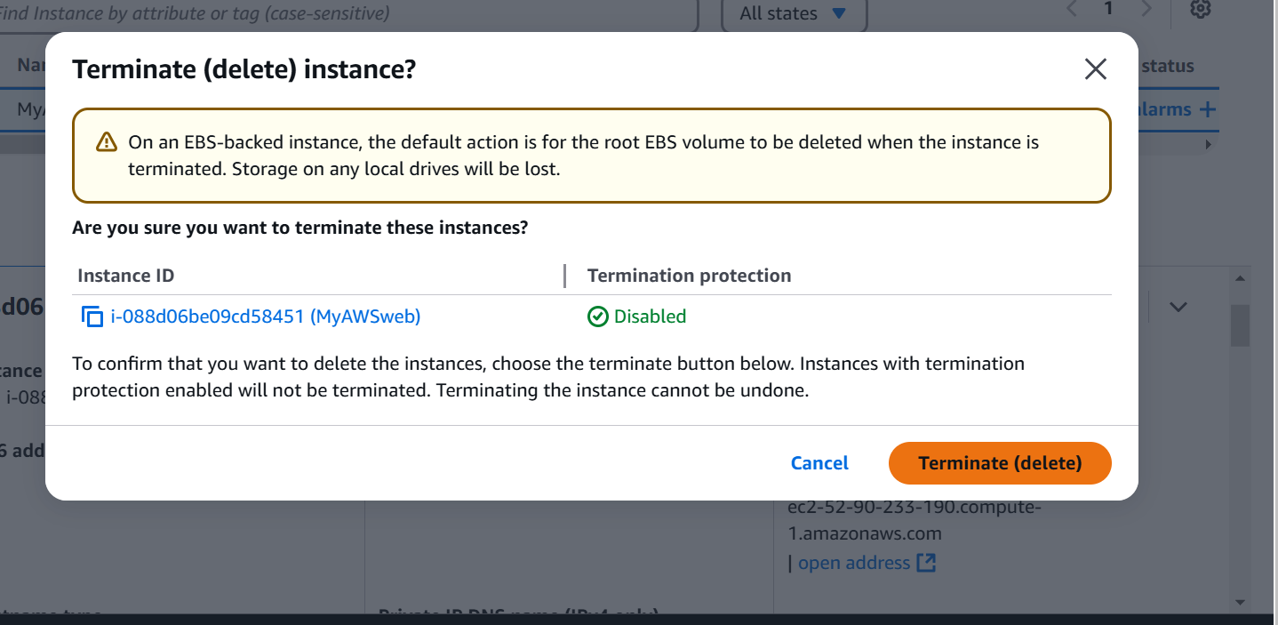

**Check if the state is terminated or not under Instance State.**

**Click on End Lab**

**Click on Yes.**